**SIGN LANGUAGE TRANSLATOR USING**

**MACHINE LEARNING**

**A PROJECT REPORT**

***Submitted by***

**KOLLIPARA HEMANTH GUPTA (111515106064)**

**MADANA NAREN GURU SAI (111515106070)**

**MALEPATI KALYAN KUMAR CHOWDARY (111515106076)**

**MAVULURU VISWAJITH REDDY** (**111515106083)**

***In partial fulfilment for the award of the degree***

***of***

**BACHELOR OF ENGINEERING**

**IN**

**ELECTRONICS AND COMMUNICATION ENGINEERING**

 

**R.M.D ENGINEERING COLLEGE, KAVARAIPETTAI**

**ANNA UNIVERSITY : CHENNAI 600 025**

**MARCH 2019**

**ANNA UNIVERSITY: CHENNAI 600 025**

**BONAFIDE CERTIFICATE**

Certified that this report **“SIGN LANGUAGE TRANSLATOR USING MACHINE LEARNING”** is the Bonafide work of

**KOLLIPARA HEMANTH GUPTA (111515106064)**

**MADANA NAREN GURU SAI (111515106070)**

**MALEPATI KALYAN KUMAR CHOWDARY (111515106076)**

**MAVULURU VISWAJITH REDDY** (**111515106083)**

who carried out the project work under my supervision.

**SIGNATURE SIGNATURE**

**Dr.K.HELENPRABHA, M.E., Ph.D. Dr.K.HELENPRABHA,M.E.,Ph.D**

**HEAD OF THE DEPARTMENT, SUPERVISOR,**

**PROFESSOR PROFESSOR**

Electronics and Communication Electronics and Communication

Engineering, Engineering,

R.M.D. Engineering College, R.M.D. Engineering College,

Kavaraipettai-601206. Kavaraipettai-601206.

The Viva-Voce Examination for the students who have submitted this project work is held on ………………………………….

**Internal Examiner External Examiner**

**ACKNOWLEDGEMENT**

At the outset, we would like to express our gratitude to our beloved and respected Thiru.**R.S. MUNIRATHINAM**, Chairman, R.M.D. Engineering College.

We would like to thank **Thiru.R.M. KISHORE**, Vice Chairman for his encouragement, and our deepest gratitude for **Dr.N.ANBUCHEZHIAN B.E, M.S, M.B.A, M.E, Ph.D.,** Principal for his support during the course of the project.

We express our sincere gratitude to **Dr. K.HELEN PRABHA, M.E., Ph.D., Professor, Head of the Department** and, **Dr.A.SUMAIYA BEGUM,M.E.,Ph.D. Associate Professor/Project coordinator, of Electronics & Communication Engineering,** for their valuable guidance and useful suggestions during the course of project.

Our sincere thanks to our Internal Guide **Dr. K. HELEN PRABHA, M.E., Ph.D., Professor, Head of the Department of Electronics & Communication Engineering,** for having extended her fullest co-operation and guidance. We also thank for her constant support and patience. We also take this opportunity to thank all the staff of our department for having encouraged us in completing this project successfully.

We also thank our Parents and friends for their unparalleled love and moral support & finally the Almighty for showering generous blessings on us, without whom we would have not gone this far

**ABSTRACT**

Communication between speakers and non-speakers can be problematic, inconvenient, and expensive. Speech impaired people are detached from the mainstream society due to the lacking of proper communication aid. Sign language is the primary means of communication for them which normal people do not understand.Around 360 million people are globally suffering from disability of hearing loss out of 328 million are adults and 32 million children. In the existing systems the use of microcontroller and the technique of image processing results in complexity to normal people. This project attempts to bridge the communication gap by designing a portable glove that captures the user’s gestures and outputs the translated text on a screen. The glove is equipped with flex sensors, contact sensors, and a gyroscope to measure the flexion of the fingers, the contact between fingers, and the rotation of the hand. The Bluetooth module transmits the gesture to a screen. Hand Gesture recognition is performed using HOG (Histogram of Oriented Gradients) for extraction of features from the gesture image and SVM (Support Vector Machine) as classifier. Finally, predict the gesture image with output text. This output text is converted into audible sound using TTS (Text to Speech) converter. Using this device, one day speakers may be able to communicate with others in an affordable and convenient way. It reduces the barrier between speakers and non-speakers. This project is also useful for the listeners who don’t have knowledge of the language of the speaker.

|  |  |  |
| --- | --- | --- |
| **CHAPTER NO** | **TABLE OF CONTENTS**  **TITLE** | **PAGE NO** |
|  | **ABSTRACT** | **ii** |
|  | **LIST OF FIGURES** | **v** |
|  | **LIST OF TABLES** | **vii** |
| **1.** | **INTRODUCTION** | **01** |
|  | 1.1 SIGN LANGUAGE | **01** |
|  | 1.1.2 ORIGIN OF SIGN LANGUAGE | **01** |
|  | 1.1.3 PHONOLOGY | **02** |
|  | 1.1.4 SYNTAX | **03** |
|  | 1.2 MACHINE  LEARNING | **04** |
| **2.** | **LITERATURE SURVEY** | **06** |
| **3.** | **EXISTING METHOD** | **13** |

|  |  |  |
| --- | --- | --- |
|  | 3.1 INTRODUCTION | **13** |
|  | 3.1.1 IMAGE PROCESSING | **14** |
|  | 3.2 SYSTEM DISCRIPTION | **15** |
|  | 3.3 HARDWARE SETUP | **16** |
| **4.** | **PROPOSED METHOD** | **17** |
|  | 4.1 INTRODUCTION | **17** |
|  | 4.2 USER REQUIREMENTS AND  DESIGN SPECIFICATIONS | **18** |
|  | 4.3 PROCESS FLOW | **20** |
|  | 4.4 SENSOR SYSTEM | **22** |
|  | 4.5 PROCESSING SUBSYSTEM | **31** |
|  | 4.6 OUTPUT SUBSYSTEM | **32** |
| **5.** | **EXPERMENTAL RESULTS AND DISCUSSION** | **34** |
| **6.** | **CONCLUSION** | **43** |
| **7.** | **REFERENCES** | **45** |
| **8.** | **PUBLICATIONS** | **47** |

**LIST OF FIGURES**

|  |  |  |
| --- | --- | --- |
| **FIG.NO** | **TITLE** | **PAGE NO** |
| 1.1 | machine learning | **5** |
| 1.2 | process flow | **21** |
| 1.3 | flex sensor | **22** |
| 4.5 | flex sensors | **24** |
| 5.1 | record image | **34** |
| 5.2 | confusion matrix | **35** |
| 5.3 | cmd sprint | **36** |
| 5.4 | arduino serial port | **37** |
| 5.5 | arduino plotter | **38** |
| 5.6 | accuracy | **39** |
| 5.7 | application process | **40** |
| 5.8 | training | **41** |
| 5.9 | action recognition | **42** |

**LIST OF ABBREVATION**

AI Artificial Intelligence

ANN Artificial Neural Networks (ANN )

ASCI American Standard Code for Information Interchange

ASL American Sign Language

CGI Computer Generated Imagery

DAC Data Acquisition and Control

EMG Electromyography

GPS Global positioning System

HOG Histogram of Oriented Gradients

IMU Inertial Measurement Unit

LCD Liquid Crystal Display

ML Machine Learning

SAD Sum of Absolute Difference

SL Sign Language

SVM Support Vector Machine

SEMG Surface Electromyography

VRML Virtual Reality Modeling Language

HMM Hidden Markov Mode

**CHAPTER 1**

**INTRODUCTION**

* 1. **SIGN LANGUAGE:**

Sign language is a language through which communication is possible without the means of acoustic sounds. Instead, sign language relies on sign patterns, i.e., body language, orientation and movements of the arm to facilitate understanding between people. It exploits unique features of the visual medium through spatial grammar. Trudy Sugg’s book describes sign language as the sixth most spoken language in the world. The sign language translator we have developed uses a glove fitted with sensors that can interpret the 26 English letters in American Sign Language (ASL). The glove uses flex sensors, contact sensors, and accelerometers in three dimensions to gather data on each finger’s position and the hand’s motion to differentiate the letters. Thetranslation is transmitted to the base station, which displays as well aspronounces the letter and also interfaces with the computer(Bluetooth is usedfor this purpose).

**1.1.2 ORIGIN OF SIGN LANGUAGE:**

Deaf people need sign language to communicate with each other and other deaf people.Moreover, several ethnic groups that use completely different phonologies (e.g. Plain Indians Sign Language, Plateau Sign Language) have used sign languages to communicate with other ethnic groups. The origin of the sign language is mainly related to the beginning of the history. The book of Juan Pablo

Bonet called “Reduccion de las letras Arte para ensenar a hablar los Mudos (Reduction of letters and art for teaching mute people to speak) is published in Madrid . This is accepted as the first modern treatise of phonetics, arranged a method of oral education for deaf people by using the manual signs of manual alphabet to improve their communication.However, this manual alphabet was not good, but just a way to make communication possible.The first real study of sign languages is achieved by Dr. William C. Stokoe publishedthe monograph Sign Language Structure in 1960. Some of his deaf students from the University of Gallaudet help him to propose the signs. Then he published the first American Sign Language dictionary. In this first dictionary, Dr. Stokoe organized the signs considering the position of the shape and motion. He did not consider on its English translation. This is a cornerstone and give a start for research about the Sign Language linguistics.

**1.1.3 PHONOLOGY** :

The phonology refers to the study of physical sounds present in human speech. The phonology of sign language can be defined. Instead of sounds, the phonemes are considered as the different signs present in a row of hand signs. They are taking into account the following parameters:

1. Configuration: Hand shape when doing the sign.

2. Orientation of the hand: Where the palm is pointing to.

3. Position: Where the sign is completed.

4. Motion: Movement of the hand when doing the sign (straight, swaying, circularly)

5. Contact point: Which part of the hand touch the body.

6. Plane: The sign is depending on the distance to the body.

7. Non-manual components: Information provided by the body.

For example, when the body leans front, it expresses future tense. Morphology Spoken languages have inflectional morphology and also derivational morphology. The inflectional morphology refers to the modification of words. The derivational morphology is the process of forming a new word on the basis of an existing word. Sign languages have only derivational morphology because there are no injections for tense, number or person. The most important parameters regarding morphology are represented as:

1.Degree: Mouthing.

2.Reduplication: Repeating the same sign several times.

3.Compounds: Fusion of two different words.

4.Verbal Aspect: Expressing verbs in different ways.

5.Verbal number: To express plural or singular verbs.

Reduplication is also used to express it.

**1.1.4 SYNTAX:**

It is primarily brought through a combination of word order and non-manual features.

It is described by:

1. Word order: A full structure as [topic] [subject] [verb] [object] [subject-pronoun-tag].

2. Topic and main clauses: Background information sets.

3. Negation: Negated clauses can be mentioned by shaking the head during the entire clause

4. Questions: The questions are mentioned by lowering the eyebrows.

5. Conjunctions: Separate sign in ASL is a short pause.

**1.1.5 CONCEPTS OF SIGN LANGUAGE:**

Briefly the basic knowledge about sign languages has been represented. The main linguistic characteristics used by the system are part of the Phonology section. The following parameters are considered:

1. Position: The position that the sign is occurred.

2. Motion: Movement of the hand when doing the sign (straight, swaying, circularly).

3. Plane: The distance with respect to the body.

**1.2 MACHINE LEARNING:**

Learning, like intelligence, covers such a broad range of processes that it is difficultto define precisely. A dictionary definition includes phrases such as “to gain knowledge, or understanding of, or skill in, by study, instruction, or experience,” and “modification ofa behavioral tendency by experience.” Zoologists and psychologists study learning in animals and humans. In this book we focus on learning in machines. There are several parallels between animal and machine learning. Certainly, many techniques in machine learning derive from the efforts of psychologists to make more precise their theories of animal and human learning through computational models. It seems likely also that the concepts and techniques being explored by researchers in machine learning may illuminate certain aspects of biological learning. As regards machines, we might say, very broadly, that a machine learns whenever it changes its structure, program, or data (based on its inputs or in response to external information) in such a manner that its expected future performance improves. Some of these changes, such as the addition of a record to a data base, fall comfortably within the province of other disciplines and are not necessarily better understood for being called learning. But, for example, when the performance of a speech-recognition machine improves after hearing several samples of a person’s speech, we feel quite justified in that case to say that the machine has learned. Machine learning usually refers to the changes in systems that perform tasks associated with artificial intelligence (AI). Such tasks involve recognition, diagnosis, planning, robot control, prediction, etc. The “changes” might be either enhancements to already performing systems or ab initio synthesis of new systems. To be slightly more specific, we show the architecture of a typical AI.

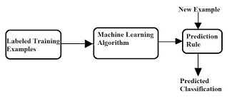

**Figure no 1.1 Block diagram for Machine Learning**

The labeled training examples are taken as input and are made to process according to the machine learning algorithm. The new example will follow the prediction rule and will be classified according to the predicted classification.

**CHAPTER 2**

**LITERATURE SURVEY**

The following literature survey gives account of the existing ideas of using the sign language conversion which aided in this project.

1.A Machine Learning Based Approach for the Detection and Recognition of Bangla Sign Language (2016)

**Muttaki Hasan, Tanvir Hossain Sajib and Mrinmoy Dey**

Communication between the speech impaired people and the normal people is difficult. This project proposes a method for 16 predefined gesture recognition using HOG features. Considering large dataset and computational efficiency SVM is an efficient approach for decision making. Many previous works has been done for detection and recognition of hand gestures but HOG feature along with audio output enables the speech impaired to communicate more efficiently. In this project, firstly we construct HOG feature based hand detector for bangla sign language detection. The final testing result shows that our method exhibits a good performance in testing. However this method is suitable for static gesture recognition. For dynamic gesture recognition we have taken first frame as input as dynamic gesture is a combination of consecutive static gesture. The number of training image can be increased for high accuracy of recognition. The recognition rate of gestures can also be increased by proper positioning and orientation of hand and proper lighting. In future we would like to introduce a portable sign language recognizer that can take hand gesture as input and gives the meaning of the gesture as an audio output.

2. Sign Language Translator and Gesture Recognition (2015)

**Elmahgiubi, M., Ennajar, M., Drawil, N., &Elbuni, M. S.**

The mute/deaf individuals have a communication problem dealing with other people. It is hard for such individuals to express what they want to say since sign language is not understandable by everyone. This paper is to develop a Data Acquisition and Control (DAC) system that translates the sign language into text that can be read by anyone. This system is called Sign Language Translator and Gesture Recognition. We developed a smart glove that captures the gesture of the hand and interprets these gestures into readable text. This text can be sent wirelessly to a smart phone or shown in an embedded LCD display. It is evident from the experimental results that gestures can be captured by set of inexpensive sensors, which measure the positions and the orientation of the fingers. The current version of the system is able to interpret 20 out of 26 letters with a recognition accuracy of 96%.

# 3.A Wearable System for Recognizing American Sign Language in Real-Time Using IMU and Surface EMG Sensors

**Jian Wu, Lu sun, & Jafari, Rozebeth safari (2016)**

A sign language recognition system translates signs performed by deaf individuals into text/speech in real time. Inertial measurement unit and surface electromyography (sEMG) are both useful modalities to detect hand/arm gestures. They are able to capture signs and the fusion of these two complementary sensor modalities will enhance system performance. In this paper, a wearable system for recognizing American Sign Language (ASL) in real time is proposed, fusing information from an inertial sensor and sEMG sensors. An information gain-based feature selection scheme is used to select the best subset of features from a broad range of well-established features. Four popular classification algorithms are evaluated for 80 commonly used ASL signs on four subjects. The experimental results show 96.16% and 85.24% average accuracies for intra-subject and intra-subject cross session evaluation, respectively, with the selected feature subset and a support vector machine classifier. The significance of adding sEMG for ASL recognition is explored and the best channel of sEMG is highlighted.

4.SignSynth: A Sign Language Synthesis Application Using Web3D and Perl.

**Angus B. Grieve-Smith**

Development of sign synthesis (also known as text-to-sign) can benefit from studying the history of its older cousin, speech synthesis. As Klatt outlines the basic architecture of a speech synthesis application, this project will discuss the architecture of a sign synthesis application and mention some of the applications and prototypes currently available. This project will focus on SignSynth, a CGI-based articulatory sign synthesis prototype that is being developed at the University of New Mexico. SignSynth takes as its input text a sign language text in ASCII-Stokoe notation (chosen as a simple starting point) and converts it to an internal feature tree. This underlying linguistic representation is then converted into a three-dimensional animation sequence in Virtual Reality Modeling Language (VRML or Web3D), which is automatically rendered by a Web3D browser.

# 5.Sign Language Recognition Application Systems for Deaf-Mute People: A Review Based on Input-Process-Output

# Suharjitoa, Ricky Andersonb , Fanny Wiryanab , Meita Chandra Ariestab , Gede Putra.(2017)

Sign Language Recognition is a breakthrough for helping deaf-mute people and has been researched for many years. Unfortunately, every research has its own limitations and are still unable to be used commercially. Some of the researches have known to be successful for recognizing sign language, but require an expensive cost to be commercialized. Nowadays, researchers have gotten more attention for developing Sign Language Recognition that can be used commercially. Researchers do their researches in various ways. It starts from the data acquisition methods. The data acquisition method varies because of the cost needed for a good device, but cheap method is needed for the Sign Language Recognition System to be commercialized. The methods used in developing Sign Language Recognition are also varied between researchers. Each method has its own strength compare to other methods and researchers are still using different methods in developing their own Sign Language Recognition. Each method also has its own limitations compared to other methods. The aim of this paper is to review the sign language recognition approaches and find the best method that has been used by researchers. Hence other researchers can get more information about the methods used and could develop better Sign Language Application Systems in the future.

**6.** Electronic speaking system for speech impaired people: Speak up

**Ahmed, S., Islam, R., Zishan, M. S. R., Hasan, M. R., & Islam, M. N. (2015).**

Sign Language is the only way of communication for speech impaired people. But general people can't understand the sign language so it becomes difficult for a speech impaired person to communicate with them. In this project an electronic speaking system was developed to ease the communication process of speech impaired people. A glove was developed which consists of five flex sensors. When a gesture is made with the glove, the change in resistance of flex sensors fed into the Arduino Nano and specific prerecorded audio command for that gesture is played from SD card through speaker and the text command for that gesture is displayed on the LCD. There are four gestures that are designed for user input so that user can play his/her chosen audio commands using those gestures. This device not only helps a speech impaired person to communicate with a normal person via audio commands but also helps him/her to communicate with a hearing impaired person by displaying the text commands on the LCD.

### 7.MonVoix - An Android Application for hearing impaired people

#### Rachana Kamat, Aishwarya Danoji, Aishwarya Dhage, Priya Puranik, Sharmila Sengupta(2016)

Human communication is the most valuable foundation in developing a cooperative environment for sharing information and knowledge by interactive sessions. Normal individual vocalizes his views through shared intentions like facial expressions and hand gestures. People with acoustical disabilities are obligated to rely on interpreters for day-to-day conversations. Interpretation of various Sign Languages is important as it will shorten the social drift and act as an agent of communal integration. This paper proposes an Android Application for a coherent interpretation of Sign Languages. MonVoix- a French remark for my voice, would act as a boon for the deaf and the mute by completely eliminating the requisite of a human interpreter. This approach utilizes a user’s Smartphone camera to capture a series of hand gestures and convert the image file to the corresponding message and audio using image processing techniques and database emulation for identification of image.

8.Translating Indian Sign Language to text and voice messages using flex sensors

**SachinBhat, AmrutheshM,Ashik, Chidanand Das, Sujith**

Communication plays an important role for human beings. Communication is treated as a life skill. Keeping these important words in mind we present our paper to mainly focused on aiding the speech impaired and paralysed patients. Our work helps in improving the communication with the deaf and dumb using flex sensor technology. A brief description about various gestures and the implementation part is discussed in this paper. A device is developed that can translate different signs including Indian sign language to text as well as voice format. Flex sensors are placed on hand gloves for the use of above said people. Flex sensor‟s resistance changes according to the flexion experienced.Sensors in the glove pick up gestures and transmit that to text data withthe help of Analog to Digital convertor and

microcontrollers. This converted text data will be sent wirelessly via Bluetooth to a cell phone which runs Text to Speech software and incoming message will be converted to voice.

Here devicerecognises Indian sign language alphabets, numbers and symbols based on sensor movement.

9. Speaking Gloves for Speechless Persons

**AbjhijtAuti, V. G. Puranik, Dr. A. K. Kureshi**

The main aim of the paper is to develop Electronic Speaking Glove, designed to facilitate an easy communication through synthesized speech for the benefit of speechless patients. Generally, a speechless person communicates through sign language which is not understood by the majority of people. The proposed system is designed to solve this problem. Gestures of fingers of a user of this glove will be converted into synthesized speech to convey an audible message to others, for example in a critical communication with doctors. The glove is internally equipped with multiple flex sensors that are made up of “bend-sensitive resistance elements”. For each specific gesture, internal flex sensors produce a proportional change in resistance of various elements. The processing of this information sends a unique set of signals to the PIC microcontroller and speaks jet IC which is pre-programmed to speak desired sentences. In recent years, researchers have been focusing on hand gestures detections and been popular for developing applications in the field of robotics and extended in the area of artificial or prosthetic hands that can mimic the behaviour of a natural human hand.

10. THE AMAZING DIGITAL GLOVES THAT GIVE VOICE TO THE VOICELESS

**Praveenkumar S Havalagi, Shruthi UrfNivedita(2013)**

Glove-based systems represent one of the most important efforts aimed at acquiring hand movement data. Generally dumb people use sign language for communication but they find difficulty in communicating with others who do not understand sign language. It is based on the need of developing an electronic device that can translate sign language into speech in order to make the communication take place between the mute communities with the general public possible, a Wireless data gloves is used which is normal cloth driving gloves fitted with flex sensors along the length of each finger and the thumb. Mute people can use the gloves to perform hand gesture and it will be converted into speech so that normal people can understand their expression. This paper provides the map for developing such a digital glove. It also analyzes the characteristics of the device and discusses future wok. A foremost goal of this paper is to provide readers with a basis for understanding glove system technology used in biomedical science.

**CHAPTER 3**

**EXISTING METHOD**

**3.1 INTRODUCTION**

Sign language is an expressive and natural way for communication between normal and dumb people (information majorly conveys through the hand Gesture)

1. The main motto of the sign language translation system is to translate the normal sign language into speech and to make easy contact with the dumb people. In order to improve the life style of the dumb people the proposed system is developed. Sign language uses both physical and non-physical communication

2. The physical gesture communication consists of hand gestures that convey respective meaning, the non physical is head movement, facial appearance, body orientation and position. Sign language not a universal language and it is different from country to country. So, the allocation of symbols and the respective meaning for the sign changes from one place to other.

3. British developed British sign language system (BSL) and Thailand developed Thai sign language system (TSL) and America has their own sign language.

4. Most of spoken English countries follow same sign language but Same sign represents the different meaning and depends upon to their own language.

Research in the sign language system has two well known approaches are

1. Image processing and

2. Data glove.

**3.1.1 IMAGE PROCESSING:**

An image is defined as a two – dimensional function, f(x,y) that carries some information, where x and y are known as spatial or plane coordinates.A digital image is created through the process of digitization. pixels are small individual elements of a digital image. The image processing technique uses the camera to capture the image/video . Analysis the data with static images and recognize the image using algorithms and produce sentences in the display, vision based sign language recognition system mainly follows the algorithms are Hidden Markov Mode (HMM).Artificial Neural Networks (ANN ) and Sum of AbsoluteDifference(SAD) Algorithm use to extract the image and eliminate the unwanted background noise.

. The main drawback of vision based sign language recognition system image acquisition process have many environmental apprehensions such as the place of the camera , background condition and lightning sensitivity. Camera place to focus the spot that capture maximum achievable hand movements, higher resolution camera take up more computation time and occupy more memory space .user always need camera forever and can not implement in public place.

**3.1.2 DATA GLOVE:**

Data glove consists of flex sensor and motion tracker. Data are directly obtained from each sensor depends upon finger flexures and computer analysis sensor data with static data to produce sentences. Its using neural network to improve the performance of the system. The main advantage of this approach less computational time and fast response in real time applications. Its portable device and cost the device also low.

Data glove especially made up of electronic glove worn by the user. It consists of flex sensors that used to detect finger gestures and transmit the information to a PIC microcontroller. Microcontroller processes the gesture of the user and plays the audio file corresponding gesture. The voice signals are then stored in storage unit. This system avoids PC intervention for processing and all operations are controlled by microcontroller. Its lead in fast response of the system. Most of the commercial sign language system uses the glove technique. It's simple to attain data concerning the bending of finger flexure and three dimensional position of the hand. Computer analysis the data and produces the output like sentence or voice, compared with existing data glove and image processing technique, low computational power,highly portable and real time operation much easier to attain.

**3.2 SYSTEM DESCRIPTION :**

In this system microcontroller receives data from the glove, it consists of inch flex sensors and gyro sensors. These sensors provide a corresponding signal of finger flexures and hand motion. PIC microcontroller contain 10-bit inbuilt ADC and use to receive the analog value from the sensor. An ADC converts analog to digital value and store the value in the buffer. Then Controller compares the static data and digital value for processing to determine the gesture. According to the finger movements microcontroller play the voice (speech). Voice is stored using APR9600 is a single chip used to store high quality voice recording and Non-volatile flash memory, playback capacity for 40 to 60 seconds. APR provides random and sequential multiple messages and designers can adjust storage time depends upon user needs. The chip integrated with microphone amplifier,Output amplifier and AGC circuit. TAPE mode provides the Auto Rewind and normal option. The six pins of use for voice storage and playback capability, each pin plays the voice for 60 second duration.The RF transmitter andreceiver used for long distance communication which are specifically designed for wireless speaker and earphone.

**3.3 HARDWARE SETUP :**

The hardware model of automatic sign language translator which consists of transmitter and receiver modules. The transmitter module contains a flex sensor and RF transmitter, the flex sensors areconnected to analog channels(AD0-AD4) in PIC microcontroller and RF transmitter connected to Port B(RB0-RB7).Each pin transmits different sign language signal.

Receiver module contains PIC microcontroller,RF Receiver and APR9600.The RF Receiver connected to PORT B(RB0-RB7) in PIC Microcontroller, received signal depends upon the sign to enable the Pin of PORT B. APR9600 is connected to PORT D (RD0-RD7) and plays recorded voice depends upon the RF enable pin.

Output data are directly obtained from data glove and each sensors produce different resistance value through the combination of resistance value. Then the respective voice plays according to the combination of resistance value. The simulation output of the sign language translator , switches are flex sensors and connected to the analog voltage generator. On the opening and closing of switch produce some analog voltage and feed to the controller. It depends upon the switch input led glow (it's similar to play s voice) at thesame time virtual terminal shows the analog value.

**CHAPTER 4**

**PROPOSED METHOD**

**4.1 INTRODUCTION:**

Sign language along with the concept of machine learning is used. The prototyped design of our glove is used for the medium of communication . The overall concept of the glove design was influenced by a list of requirements relevant to sign language users, the mechanics of Sign language, and the drawbacks of the similar projects as discussed in the previous chapter. These helped to formulate three possible design approaches to this project, which narrowed down to one design. This design can be separated into gesture sensing, signal processing and data output subsystems. A discussion of each of the subsystems follows explaining their role in the integrated design.

user

Arduino Nano





bluetooth

monitor

analysis

Data collection

**proposed block diagram**

The user gives his input by the means of the flex sensors and the Mpu6050 ,the further actions are performed by the arduinonano and with the help of Bluetooth module it is given to the monitor. Data collection and analysis should be done during the process for the gesture recognition.

**4.2 USER REQUIREMENTS AND DESIGN SPECIFICATIONS:**

Several difficulties are faced by Sign Language users when communicating with those of the hearing community. Sign Language speaking adults understand these difficulties best, so requirements that they explicitly state take priority. These requirements will later be taken into consideration when deciding on product specifications.

**4.2.1EXPLICIT REQUIREMENTS:**

Based on multiple interviews with Sign Language users , there are several explicitly-stated requirements of a sign-language translating glove. These include the speed of translation and the accuracy of the device. The average Sign language user gestures about 3 signs per second and while it is not necessary during the development of our prototype for the device to match this speed the faster that it can translate as the user signs, the better. This and the glove accuracy, or if and how often it can detect and translate the correct gesture as the user signs it, determine the reliability of the glove. The device accuracy also involves the device’s ability to incorporate the various motions that signs involve. This includes not only the rotation and flexion of hands and fingers, but also the orientation of the hand with respect to the signer.

**4.2.2 IMPLICIT REQUIREMENTS:**

In addition to the requirements specified by Sign Language users, the team has defined five requirements of the device that increase the prototype’s usefulness to Sign Language users. Several aspects and interactions of the device with its users and environment were taken into consideration. The requirements are as follows:

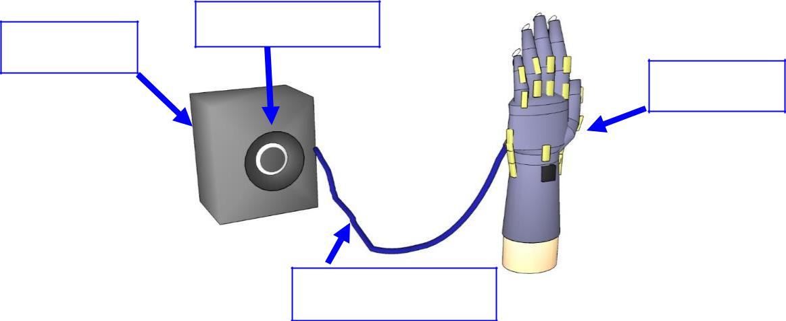**Easy to Use -** Any complications in its user interface would inhibit the glove’s use in everyday life. The user should be able to begin translation without much difficulty or delay.

**Portable -** It should be able to be brought almost anywhere the user goes, with the possible exception for underwater.

**Affordable -** Not much financial aid is available for assistive devices. This device should be accessible by the average person by practical and affordable means.

**Reliable -** There is a certain degree of accuracy that the device should maintain. This threshold has been decided by our team to be of about 86% accuracy. If the device does not accurately and consistently translate signs, then the user will resort to time consuming alternatives such as writing on pen and paper and the device will have no use.

**Aesthetically Pleasing -** For marketability purposes, the device shall be aesthetically pleasing and easily wearable without any factors that hinder convenience during extended periods of time. This includes a smooth, professional appearance without any components that irritate, cut, bruise, or otherwise cause discomfort for the user.

So, the glove must be easily available and should be easily usable to the users. The glove must affordable to the users, if the product is made in large scale then the cost reduction for individual glove can be obtained . The aesthetically pleasing is an important factor in the market purpose as it should not affect the appearance of the glove.

Functional and non functional requirements are top , and a huge number of subcategories are underneath. For testers there are only two main requirements implicit and explicit requirements. Both are equally important . The speed and accuracy are equally important as the features such as affordability ,reliability.

PRDs are most frequently written for software products, but can be used for any type of product and also for services. Typically, a PRD is created from a user's point-of-view by a user/client or a company's marketing department (in the latter case it may also be called Marketing Requirements Document(MRD)). The requirements are then analyzed by a (potential) maker/supplier from a more technical point of view, broken down and detailed in a Functional Specification(sometimes also called Technical Requirements Document).As the product focuses on the sign language and aids the people who are deaf and dumb ,the Requirements vary from the general products’ requirements.

**4.3 PROCESS FLOW:**

The process flow is initiated by the calibration process and after the input is received from the sensors, the sensors maps the reading and the process is further proceeded. Some values will be already stored in the system, If theobtained reading and the stored reading gets matched then the respective output will be displayed by the monitor .Bluetooth module is utilized for this purpose.

INPUT

(CALIBRATION)

READ SENSOR

VALUES

MAP SENSORS

READING

IF SENSORS READING = STORED

VALUES,THEN OUPUT IS

DISPLAYED ON THE MONITOR

**Figure 4.3 PROCESS FLOW OF MACHINE LEARNING**

The accuracy can be increased by the more no of data sets produces ,if the stored values are more in number then, the recognition process would become more accurate.

**4.4 SENSOR SYSTEM**

The sensor system is made up of three main components: the flex sensor circuits, the contact sensor circuits, and the gyroscope. Each type of sensor will provide its own unique data to the processor so that the processor can recognize subtle differences between gestures.

For the purposes of this project, the flex sensors will be used to determine the flexion of each finger of the hand.  Communicating between the Hearing and Non-Hearing, the positions of each finger are key determinants of which gesture is being performed. Each finger has one or two flex sensors on it . Each flex sensor will be set up in a voltage divider circuit so that it may be processed accurately .

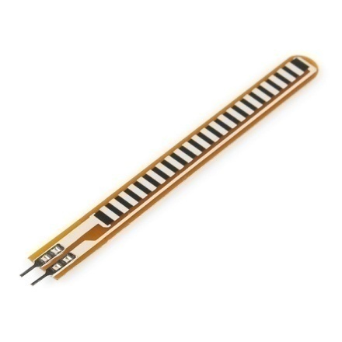



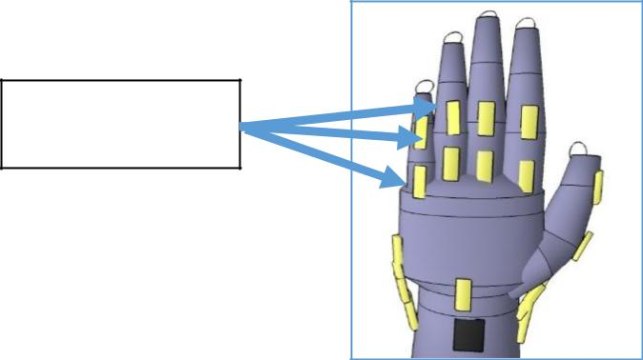

Flex sensor

**Figure 4.4 Flex sensors**

A resistive contact sensor was fixed to the tip of each finger. Measuring contact against the fingers is important to gesture recognition, as touch is one of the key mechanics of Sign Language. Another important consideration in communication devices is safety standards. To bringa device as close as possible to becoming a commercial product, there should be care taken to follow allsuggested and required standards related to safety. As with any electronic equipment, there is a risk ofshorting wires, which can result in injury or fire. In terms of electrocution, our glove will not cause injuryfrom electrocution, because according to a research completed ,the “lowest lethal voltage” is 25V.

One risk common to wearable devices is chemical burns from overheated or poorly constructedbatteries. These risks can occur if the batteries are stressed or heated. In the glove, the batteriesused are Duracell AAA batteries. According to the datasheet, the batteries can operate at temperaturesbetween -20 Celsius and 54 Celsius. Another standard is UL 60065, which in a few words requiresthat electronic devices have protections against overvoltage . The sign language glove design of thisproject only has one power supply and no possibility of voltage spikes above the specified voltage of4.5V.

The contact sensors used are FSR-400 contact sensors, which were set up to provide digital output (either 0 V or 5 V) using a simple pull-down setup described in the technical background.

A three-axis gyroscope combinational sensor was to be attached to the top of the wrist. This location will allow for simple and short interfacing with the microprocessor if used.

**4.4.1 FLEX SENSORS**

This flex sensor is a variable resistor like no other. The resistance of the flex sensor increases as the body of the component bends. Sensors like these were used in the Nintendo Power Glove. They can also be used as door sensors, robot whisker sensors, or a primary component in creating sentient stuffed animals. Flex sensor is used in wide areas of research from computer interfaces, rehabilitation, security systems and even music interfaces.It is also famous among students and Hobbyists.

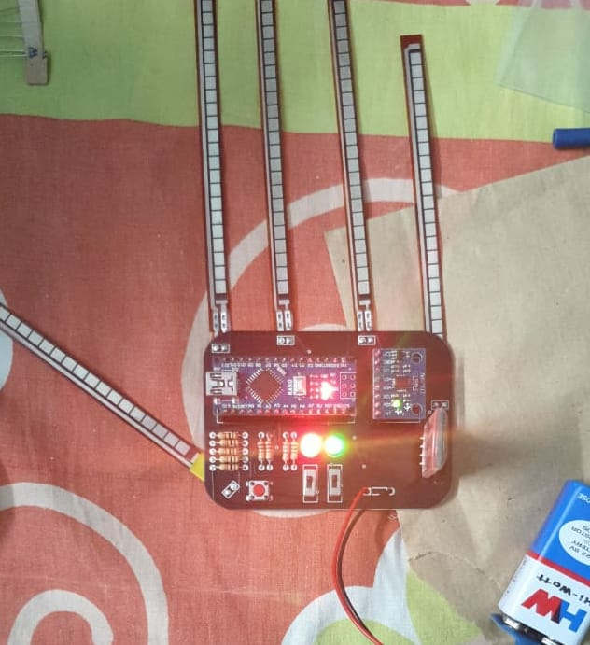

**Figure 4.4.1flex sensors**

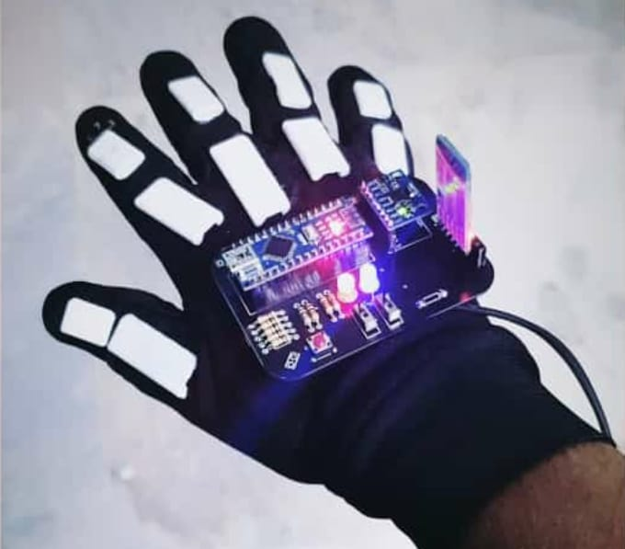

4.4.2 ANALOG MULTIPLEXERS

In electronics, a multiplexer (or mux) is a device that combines several analog or digital input signals and forwards them into a single output line. A multiplexer of inputs has select lines, which are used to select which input line to send to the output.

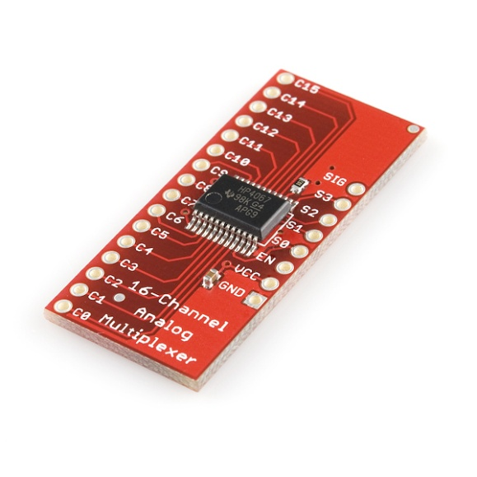**figure 4.4.2 analog multiplexer**

**4.4.3 BLUETOOTH MODULE HC05**

The Bluetooth module HC-05 is a MASTER/SLAVE module.By default the factory setting is SLAVE.The Role of the module (Master or Slave) can be configured only by AT COMMANDS.The slave modules cannot initiate a connection to another Bluetooth device, but can accept connections.Master module can initiate a connection to other devices.The user can use it simply for a serial port replacement to establish connection between MCU and GPS, PC to your embedded project, etc.

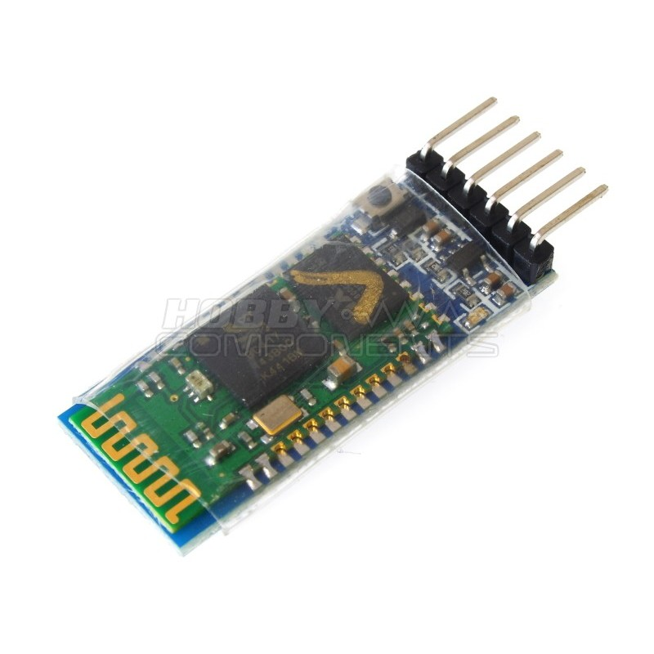**figure 4.4.3 bluetooth module**

4.4.4 MPU6050

The MPU-6050 is the world’s first and only 6-axis motion tracking devices designed for the low power, low cost, and high performance requirements of smartphones, tablets and wearable sensors. The MPU 6050 is a 6 DOF (degrees of freedom) or a six-axis IMU sensor, which means that it gives six values as output: three values from the accelerometer and three from the gyroscope. The MPU 6050 is a sensor based on MEMS (micro electro mechanical systems) technology.

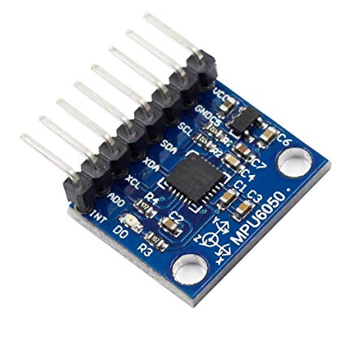

**Figure 4.4.4 mpu6050**

4.4.5 CONFUSION MATRIX

A confusion matrix is a table that is often used to describe the performance of a classification model (or "classifier") on a set of test data for which the true values are known. The confusion matrix itself is relatively simple to understand, but the related terminology can be confusing .The confusion matrix is a two by two table that contains four outcomes produced by a binary classifier. Various measures, such as error-rate, accuracy, specificity, sensitivity, and precision, are derived from the confusion matrix. Confusion Matrix. A confusion matrix, also called a contingency table or error matrix, is used to visualize the performance of a classifier. The columns of the matrix represent the instances of the predicted classes and the rows represent the instances of the actual class.

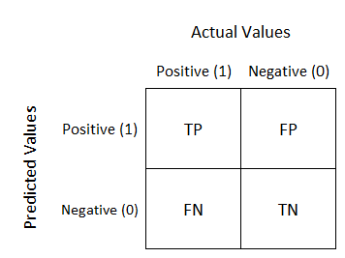

**4.4.6 CONDUCTIVE THREAD**

Conductive thread can carry current the same way that wires can, which means it can be used to create a circuit. This allows the user to sew a circuit together, creating flexible circuits that require no soldering. In some textile-based projects, this is the most practical tool to maintain the hang of the fabric.

**4.4.7 ARDUINO NANO V3.0**

The Arduino nano is a small, complete and bread-board friendly board based on the ATmega328P (Arduino Nano 3.x). It has more or less the same functionality of the arduinoduemilanove, but in different package. It lacks only a DC power jack, and works with a Mini-B USB cable instead of a standard one.The Arduino Nano can be powered via the Mini-B USB connection, 6-20V unregulated external power supply (pin 30), or 5V regulated external power supply (pin 27). The power source is automatically selected to the highest voltage source.

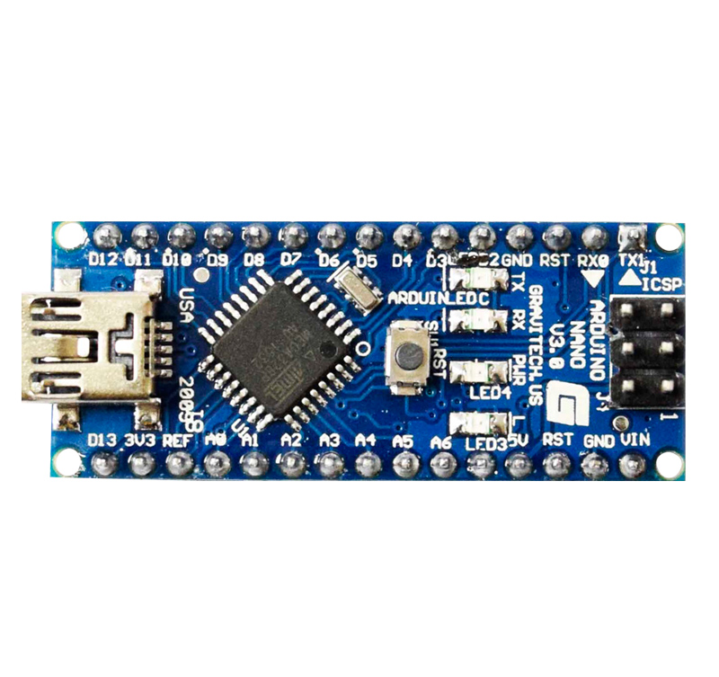

**figure 4.4.7 Arduino nano**

**4.4.8 ARDUINO SERIAL PLOTTER**

The Arduino Serial Plotter is a Tool that comes pre-installed with your Arduino IDE that takes incoming serial data and displays them in a plot. The vertical Y axis adjusts as the value of your serial data increases or decreases. The X axis has 500 points and each tick of the axis is equal to an executed Serial.println() command. This means that the plot is updated every time you use the Serial.println() command with a new value .

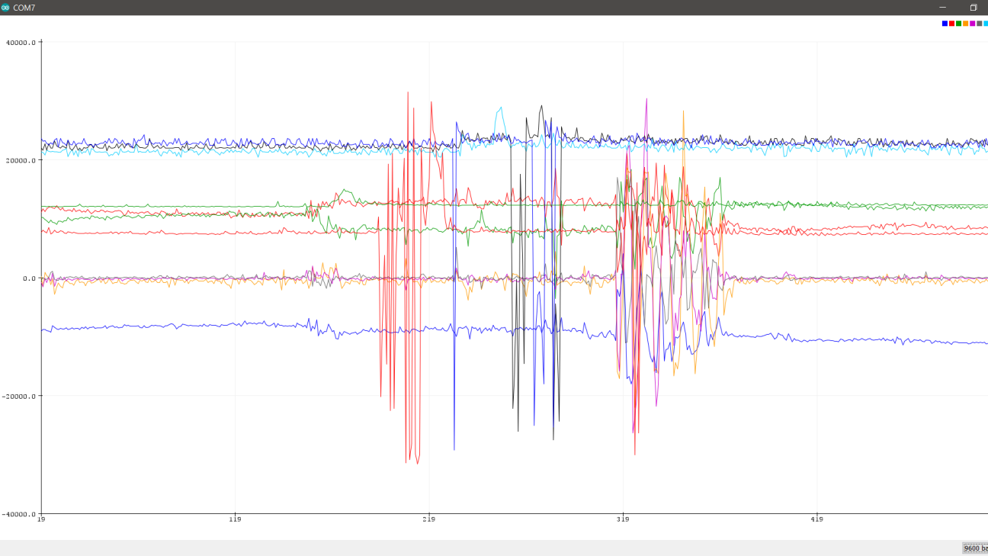

**4.4.9 SUPPORT VECTOR MACHINE:**

Support vector machines (SVMs), also known as support vector networks, are a set of related supervised learning methods used for classification and regression. Given a set of training examples, each marked as belonging to one of two categories, an SVM training algorithm builds a model that predicts whether a new example falls into one category or the other. An SVM training algorithm is a non-probabilistic, binary, linear classifier, although methods such as Platt scaling exist to use SVM in a probabilistic classification setting. In addition to performing linear classification, SVMs can efficiently perform a non-linear classification using what is called the kernel trick, implicitly mapping their inputs into high-dimensional feature spaces.

**4.5 PROCESSING SUBSYSTEM:**

To process the incoming signals, each analog signal from the flex sensors must be converted to a digital signal. This means that to process all eight of the flex sensors, eight channels of ADC are required. Most microcontrollers come with some analog input pins, but this number is limited and can quickly crowd up the microcontroller. The addition of ADCs can be used to add more analog pins to the overall processing system. One option, the mpu6050 allows for up to 8-channels of conversion with 10 bits of resolution and a sampling rate of 200ksps. This means its samples of the flex sensor voltage will have a sensitivity of 5V/2^10 = 4mV per bit, captured twice every millisecond, which is more than sufficient.

**4.6 OUTPUT SUBSYSTEM**

After all sensor outputs are connected to the microcontroller input, the processing can begin using a machine learning algorithm. Although it would be possible to hard-code each gesture into the microcontroller algorithm, this would create difficulties when updating or expanding the number of recognizable gestures. The initial approach will be a lookup table with some machine learning aspects. It will use a library of training data to learn from the average sensor inputs for each gesture, with tolerances for each gesture set by the machine learning algorithm. The tolerances are flexible so that the glove will be able to adapt to different users.This system is the final step in implementing translation. After the gesture has been recognized, the output will transmitted to a smartphone or screen via Bluetooth. Then, the name of the recognized gesture will be printed on the smartphone’s screen or any respective screen, so that people who are watching the smartphone or screen can understand the gesture.The basic functionality is to wirelessly connect a device to the glove, receive sensor data from the glove, run the glove’s classification algorithm, and write the output clearly to the smartphone screen. Additional features included using text-to-voice software, so that the phone would “speak” the translated gesture, and increasing the number of known gestures potentially up to thousands of gestures. These features are intended to reduce the complexity of using the glove in everyday and emergency situations, however for the purposes of this project we found that it was best to limit our output to just text.

**CHAPTER 5**

**EXPERIMENTAL RESULTS AND DISCUSSION**

**RECORD IMAGE:**

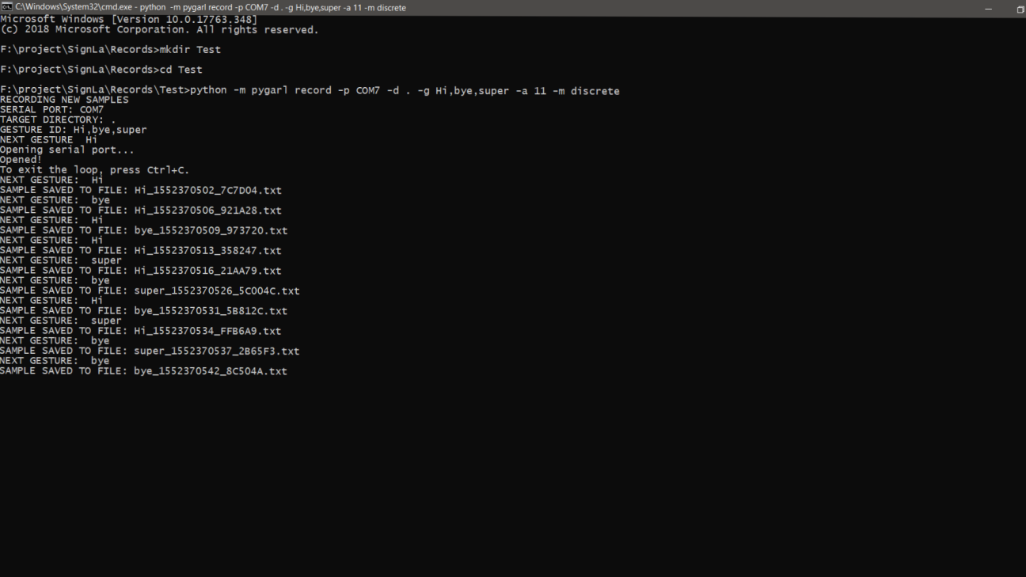

**Figure 5.1 Pygral recording image**

The pygarl record is used for the checking of saved samples. Here the following image consists of the three samples.selecting com s-print gives the serial print. The serial print is not useful for data extraction.-p gives the port to be selected and –m gives the module to be selected. The records must be created. Each sample like “hi” has a descrete directory.

**CONFUSION MATRIX:**

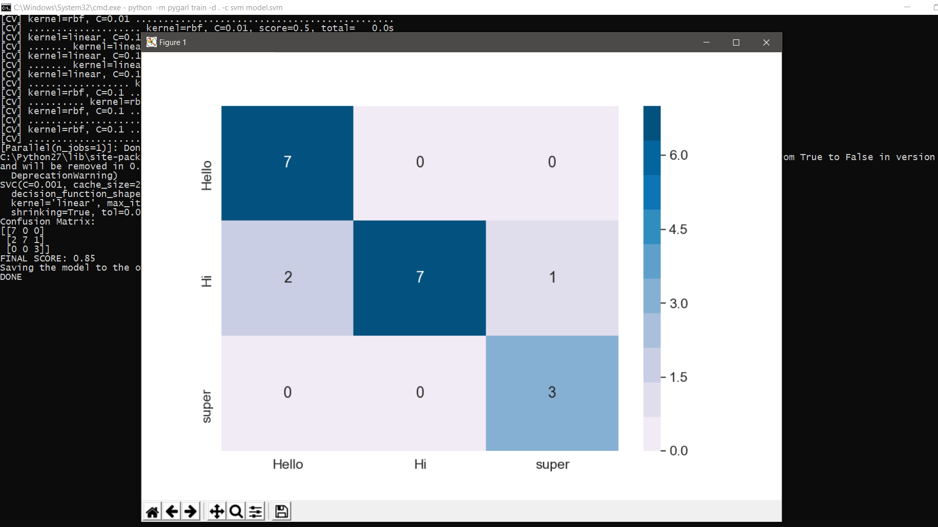

**Figure 5.2 Confusion Matrix**

Confusion matrix consists of rows and columns of the created samples. The samples created consists of data sets .Set is an array of numbers created in a periodic time. Two data sets are created per second. Creating too many samples for one object will affect the accuracy. One among the vertical or horizontal should be selected. Closer relation between the rows and columns would create the confusion and gives information about accuracy.

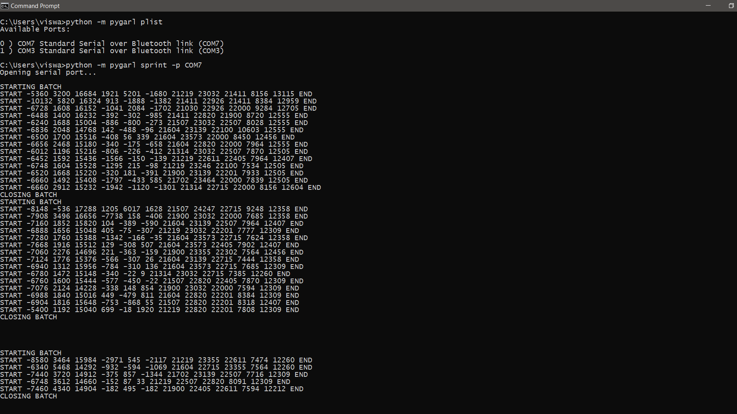

**Figure 5.3 Data set samples**

The samples created would have data sets. The each number in the row have its own specification. The first three numbers in the row are the readings of the gyroscope . The second three reading the row followed by are the readings are the accelerometer and the remaining numbers represent the fingers .each finger is assigned to a number in the row.

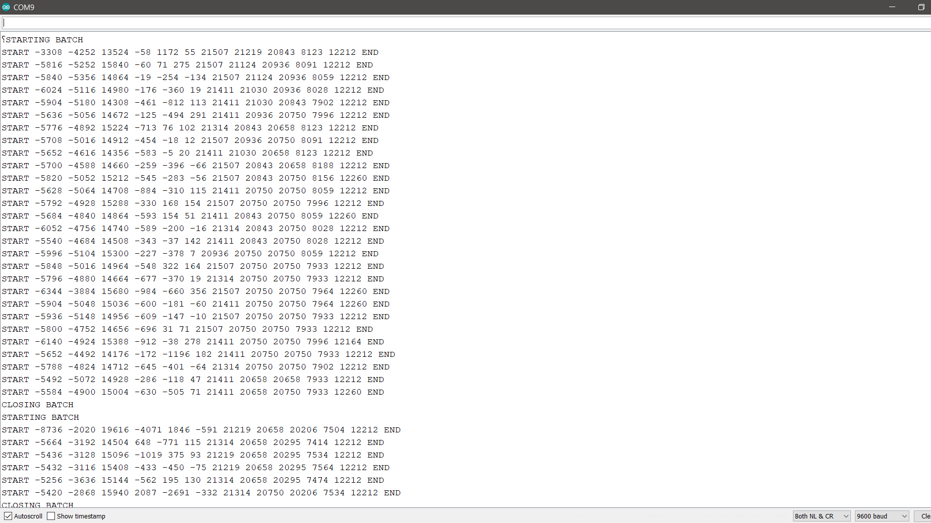

**Figure 5.4 starting and the closing batch of data sets**

The starting batch and the closing batch is the interval where the readings are taken .The interval may be as long as the switch is pressed and the gestures are given .



**Figure 5.5 arduino plotter**

The IDE is connected to arduino .The above graph is used to check whether the readings are changing according to the movement of the fingers .it gives account of the three readings of all the fingers assigned to it. Any change in the movement of the finger according to the gesture produced would affect the graph.

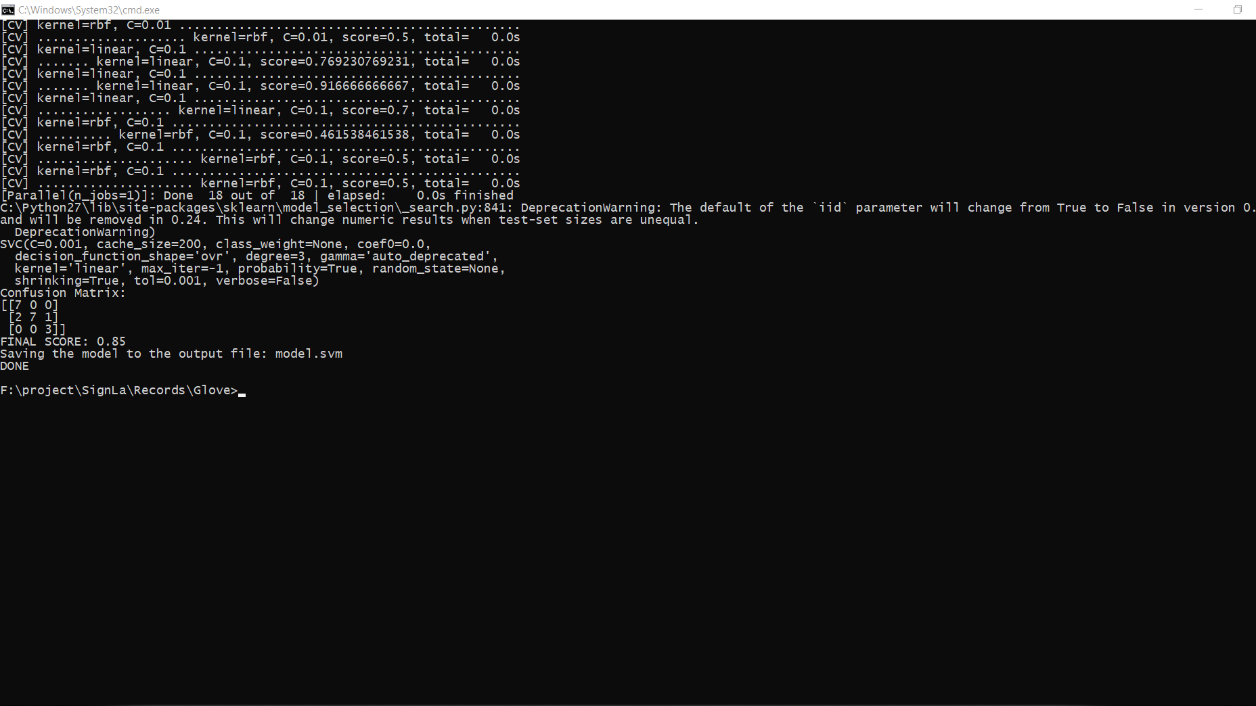

**Figure 5.6 accuracy of data samples**

The accuracy can also be found out as above. The increase in the samples would give the higher rate of accuracy. The probability of giving accurate results will be more if the more number if inputs are given to the system. The increased number of data samples will give the system to differentiate between the signs.

For Graphical User Interfacing ,flask micro-framework has been used:

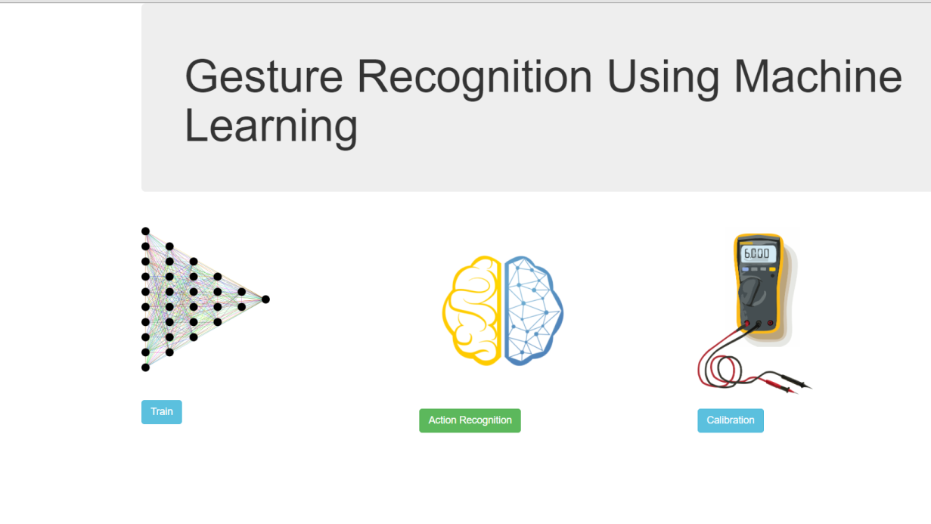

**Figure 5.7 application process**

The three important phases involved in the application are

1)Training

2)Action recognition

3)Calibration

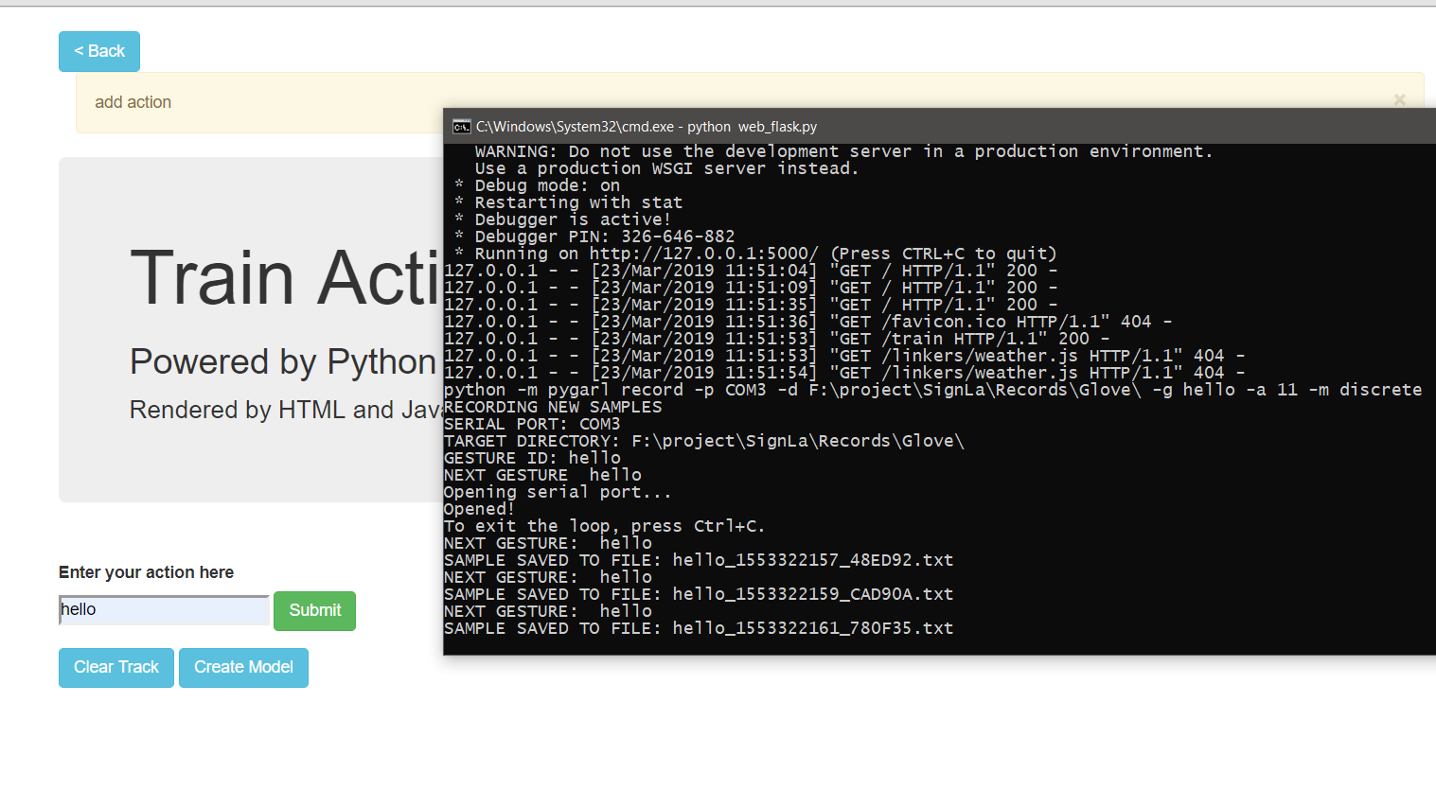

**Figure 5.8 training**

Training is the first process involved here. The training action takes the required inputs from the user’s gestures and gets trained with the available data samples. It consists of certain loops in which the training action terminates.

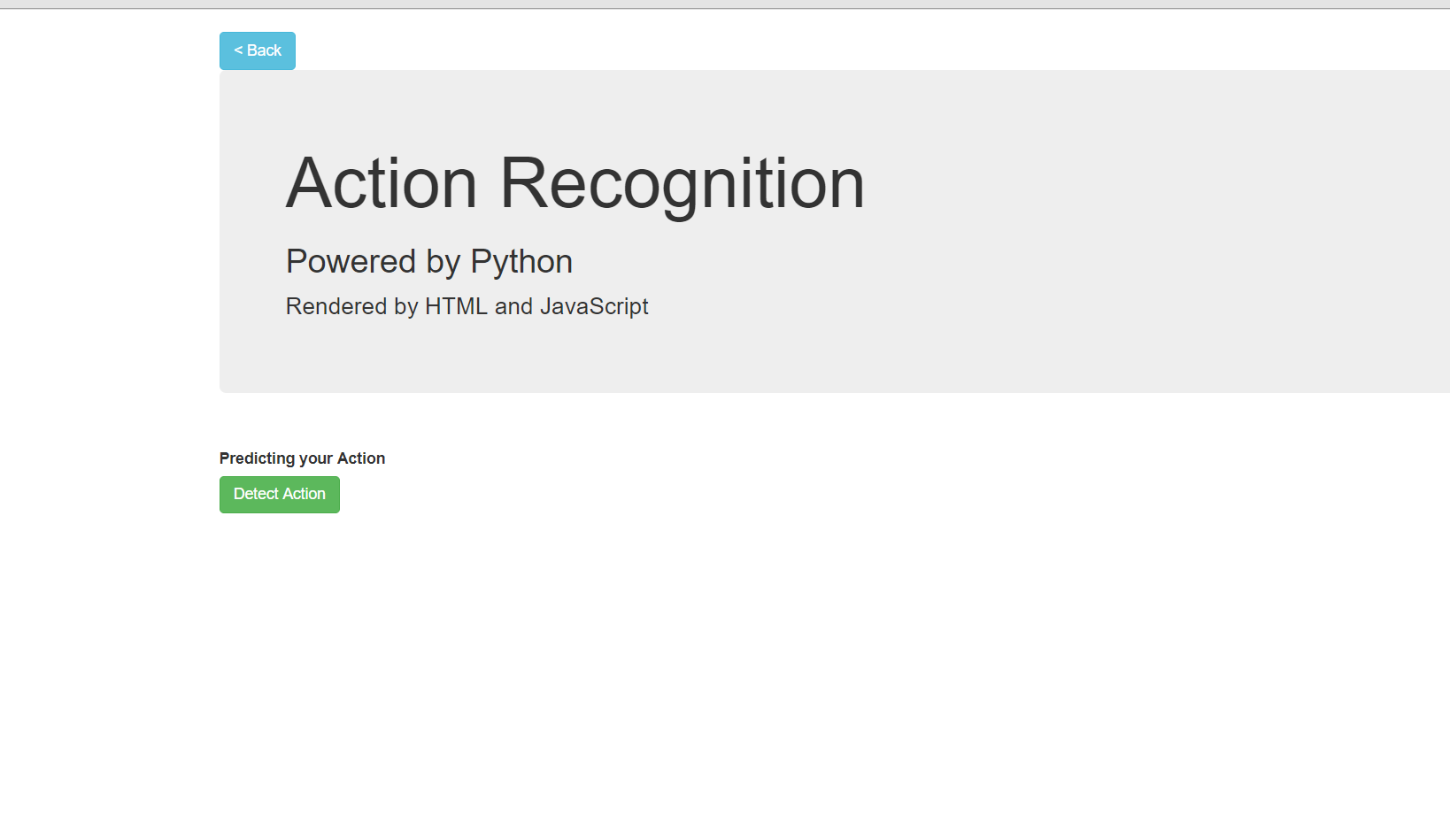

**Figure 5.9 action recognition**

Action recognition is the final process. The action recognition process is in which where the available data sets gets checked with the action or gestures performed by the user. If the gesture performed has the available information in the data then the action gets recognized.

**CHAPTER 6**

**CONCLUSION**

This report brings out the result to translate the central Indian sign language using M.L (machine learning) to receive the input data that used to create the prediction model with optimized selected feature which will ensure the correct mapping of the gesture performed and the translation. This process provides a better way to aid the conversion process. The idea of combining machine learning and sign language conversion is successful with the proof of expecting output.

The process is non robust and sensitive. Higher degree of accuracy is possible with increased samples, even there are few mathematical computations,the model provides output with maximam efficiency.

The developed models are able to make it up to an accuracy of 86% with forty attributes used out of an 80 attributes.The prediction model is able to translate all three signs correctly.

However the accuracy rate altered by the collected data.The data collected from the expert gives a better distinguish between signs than non expert.

**FUTURE WORK:**

The future work has to be done upon the samples taken and the accuracy using the deep learning in order to improve the gesture recognition and higher rate of accuracy and to compare the gestures. The project may also be useful for removing the barrier between the speaker and listener who are not aware of each others language. It will be useful in the communication in the places where the possibility of communication through languages is less.

**REFERENCES**

1. Mohammed Elmahguibi. Sign language Translator and Gesture Recognition. 978-1-4673-6857-1,2015 IEEE Journal,
2. Jian wu, LU sun, RoozbehJafari.A wearable system for recognition American Sign Language in Real time Using IMU and Surface EMG Sensors. JBHI-00032,2016 IEEE Journal.
3. A.B.Grieve Smith, Sign synth, 134-145,2012 IEEE Journal.
4. Suharjito, Ricky Anderson, Sign language recognition Application systems for deaf/mute people, 116-2017/441-448, Referred from Cambridge,2017 IEEE Journal.
5. MuttakiHassan,TanvirHossianSajib and Mrinmoy Dey, Machine Learning Based Approach for the detection And Recognition of Bangla Sign Language,978-1-5090-5421-3/16,2016 IEEE Journal.
6. Ahmed, S., Islam, R., Zishan, M. S. R., Hasan, M. R., & Islam, M. N. Electronic speaking system for speech impaired people: Speak up 15570498,2015 IEEE Journal
7. Rachana kamat,AishwaryaDanoji, AIshwaryaDHange, Priya Puranik,SharmilaSenugupta(2016)MonVoix - An Android Application for hearing impaired people Journal of Communications Technology, Electronics and Computer Science, Issue 8, 2016 ISSN 2457-905X

8.SachinBhat, AmrutheshM,Ashik, Chidanand Das, Sujith

Translating Indian Sign Language to text and voice messages using flex sensors International Journal of Advanced Research in Computer and Communication Engineering Vol. 4, 2015

9.Abjhijt Auti, V. G. Puranik, Dr. A. K. Kureshi Speaking Gloves for Speechless Persons,10.17148/IARJSET,2017

10.Praveenkumar S Havalagi, Shruthi UrfNivedita(2013) the amazing digital gloves that give voice to the VOICELESS 2231-1963,International Journal of Advances in Engineering & Technology, Mar. 2013.

**PUBLICATIONS**

SIGN LANGUAGE TRANSLATOR USING MACHINE LEARNING published in International Journal of Innovative Research Technology(IJIRT) e-journal, Volume 5, Issue 10, March 2019 .